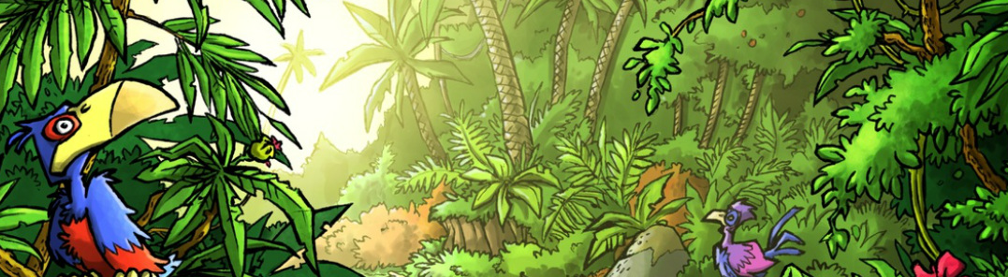
Mini Safari Seven

Name:_________________________________________________________________

This mini research safari is designed to get you searching for answers using a range of online search tools. Look at the question carefully to see what kind of information it is asking you to provide.

- Name three animals/ insects that have a three-stage life cycle?

- Name as many members of the ape family as you can?

- What is Madame Curie most famous for?

- What are coniferous trees?

- What countries border France?

- Translate the following into Hindi? My favourite colour is blue and my favourite fruit is a peach.

- Which of the following would give you more value in Australian dollars EU €256.00 (Euro) OR £256.00 British Pounds

- If it is 10am in Edinburgh, Scotland, what time is it is Auckland, New Zealand?

- Which of these is NOT a grain crop? Wheat, barley, soybeans, oats, canola, sunflower.

- Which fruit contains more calories? 1 orange or 1 peach?

