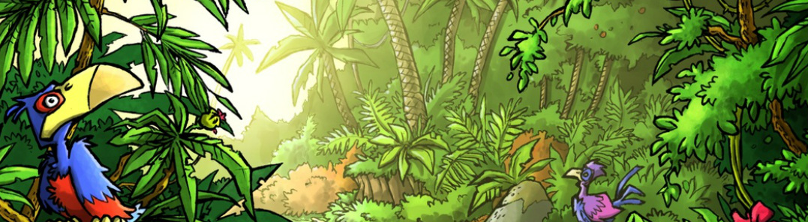

Mini Safari One

Name:_________________________________________________________________

This mini research safari is designed to get you searching for answers using a range of online search tools. Look at the question carefully to see what kind of information it is asking you to provided.

- Which black and red insect loves to eat aphids?

- What is glass made from?

- Who was born first - Mozart or Beethoven?

- If you eat a legume what are you eating? Give three examples.

- What country was formerly Persia?

- Where did the mutiny on the Bounty occur?

- For today what is the exchange rate for one hundred American dollars into Indian Rupee?

- If it is 8am in Paris, France, what time is it is Sydney Australia?

- How is coffee decaffeinated?

- Which nuts contain more calories? 100gm peanuts or 100 gm walnuts?

