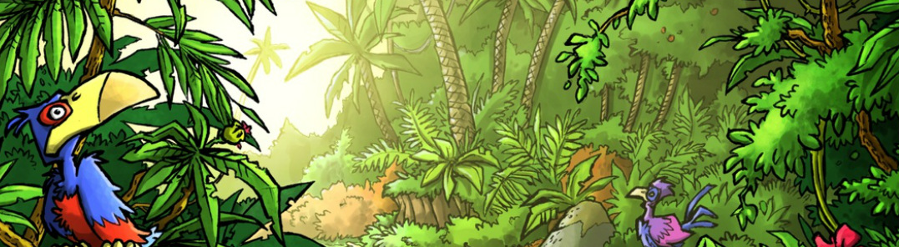
Mini Safari Eight

Name:_________________________________________________________________

This mini research safari is designed to get you searching for answers using a range of online search tools. Look at the question carefully to see what kind of information it is asking you to provide.

- What is the difference between a bee, a wasp and hornet?

- If someone is lactose intolerant what does that mean?

- Who is the real person that Alice from Alice in Wonderland based on?

- If a tree is deciduous what does that mean?

- What is the shortest distance across the English Channel between England and France?

- What is Culloden famous for?

- Which of the following would give you more value in Rupee EU €125.00 (Euro) OR US $125.00 American dollars

- What is special about Lake Eyre in Australia?

- What is the unit of measurement for the length of wool that is taken from a sheep when it is shorn?

- Name 10 different kinds of nuts you can eat.

