Creative Commons

Match the Creative Commons symbol with the correct definition or description.

Share Alike
You can distribute derivative works only under a license identical to the license that governs your work
No Derivative Works
You can copy, distribute, display, and perform only verbatim copies of this work, not derivative works based upon it.
Attribution
You can copy, distribute, display, and perform this copyright work – and derivation works based upon it – but only if the artists is given credit
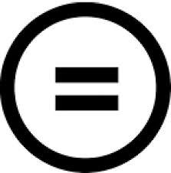 | Creative Commons  Creative Commons is an international non-profit organisation that provides free licences and tools that copyright owners can use to allow others to share, reuse and remix their material, legally.
Noncommercial
You can copy, distribute, display, and perform this work – and derivatives based upon it – but for non-commercial purposes only.

