Bees

Clade: Anthophila  Kingdom: Animalia  Order: Hymenoptera  Class: Insecta  There are thousands of bee species around the world. In Australia alone there are over 1700. Many are native (they come from Australia) however some are introduced like the European Honey Bee. Bees are very important to the environment. Let’s find out WHY. | 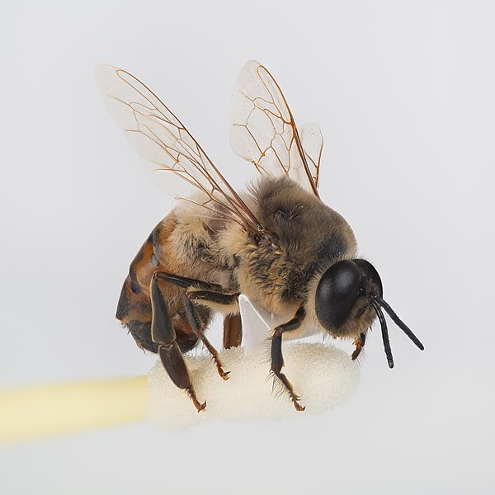
KEYWORDS
bee; pollen; pollinate; hive; worker bee; drone; queen bee; honeycomb; wax; royal jelly; colony; swarm; sting; colony collapse; bumblebee, apiarist, bee hotel; varroa mite; sacbrood disease; fouldbrood disease; biosecurity​; native bees; food security; honey bees; bumblebees; Halictidae, beekeeping; wasp;

Add other key words you discover while you are doing your inquiry.

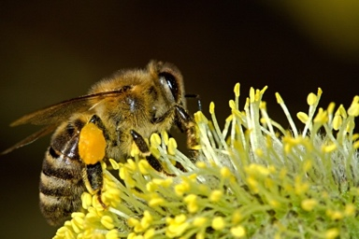

DEFINING MY TOPIC
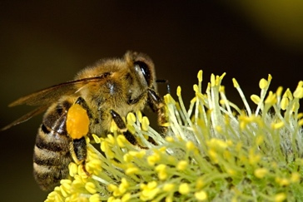
WHAT DO I ALREADY KNOW ABOUT BEES?
Jot down anything you know about bees.

BRAINSTORMING IDEAS AROUND BEES
Add ideas in each of the ‘bubbles’ about bees either that you know or want to find out.

BEES

DEVELOPING YOUR OWN FOCUS QUESTION
You have been given some examples of questions you might ask about bees. Now make up some questions of your own. Try to ask OPEN-ENDED questions. Why not use the Five Ws and H to get you started developing your questions. You can then use the QUESTION MATRIX to create more complex questions.
Questions starter | Write your questions here
Who?
What?
Where?
When?
Why?
How?

THE QUESTION MATRIX

 | EVENT | SITUATION | CHOICE | PERSON | REASON | MEANS
Present | What is? | Where / when is? | Which is? | Who is? | Why is? | How is?
Past | What did? | Where / when did? | Which did? | Which did? | Why did? | How did?
Possibility | What can? | Where / when can? | Which can? | Who can? | Why can? | How can?
Probability | What would? | Where / when would? | Which would? | Who would? | Why would? | How would?
Prediction | What will? | Where / when will? | Which will? | Who will? | Why will? | How will?
Imagination | What might? | Where / when might? | Which might? | Who might? | Why might? | How might?

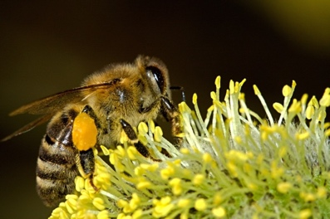
Choose one question starter form each line and column and write them below.
FOCUS QUESTIONS
Here are some questions to get you started on your inquiry. You might also like to write some questions of your own under each heading.

Habitat
Where do bees mainly live (native and commercial bees)?

Food
What do bees eat?

Lifespan
How long do bees live?

Reproduction
Is it only the queen bee that reproduces?
How many bee larvae are produced

Decline on bee population
What are the main causes for the decline in bee populations?

Protection
How can we help protect bee populations?

Importance in the ecosystem
What role do bees play in the ecosystem?
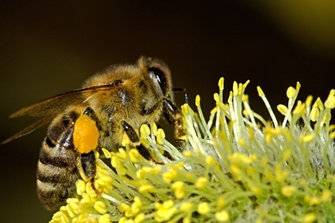

PUT YOUR THINKING HATS ON
Write down your ideas or questions about dugongs under each hat
White Hat Thinking  What facts do you know about bees | Black Hat Thinking  What negative things are harming bees?
Yellow Hat Thinking  How are bees important to the environment and the economy? | Green Hat Thinking  What are some interesting facts about bees?
Red Hat Thinking  How do people feel about bees? How do you feel about bees? | Blue Hat Thinking  What have you learned from doing this inquiry?
LOCATING YOUR INFORMATION
Resources to help with my inquiry
There are many places for you to find information about your topic but most people use the internet. Here are three resources from the internet to get you started with your inquiry about dugongs. Use then to answer the questions you have made so far.

Resource | How does this resource help with my research?
Top 10 Facts about Bees
https://www.wwf.org.uk/learn/fascinating-facts/bees
Ten Facts About Honeybees
https://www.natgeokids.com/au/discover/animals/insects/honey-bees/
Aussie Bee Website
https://www.aussiebee.com.au/

HOW GOOD ARE THE RESOURCES THAT I HAVE FOUND?

How do you know what is a ’good source’ of information when you are doing your research?
Use the RADCAB checklist to help you work out whether a resource is suitable for your inquiry.

RELEVANCE Is the information relevant to the question I am trying to answer?
APPROPRIATENESS Is the information suitable to my age and reading level?
DETAIL How much information does the resource have about dugongs?
CURRENCY Is the information up to date / current?
AUTHORITY Who is the author of the information?
What are his or her qualifications? Are they an expert in this area?
BIAS Is this information biased? Was this resource written to inform me, persuade me, entertain me, or sell something to me?

Which of the three resources above do you think is most useful and why?

WHERE CAN YOU FIND MORE INFORMATION ABOUT BEES?

Searching on the web for your resources
Did you know that there are other great search engines besides Google? Here are two others you can try. Why not compare the results from each.

www.instagrok.com | www.duckduckgo.com | www.google.com

SEARCH TERMS
Before you start searching on the web you need to choose SEARCH TERMS that are going to give you the best results. To narrow the search use the word AND to combine terms e.g.
native bee AND Australia;
beekeeping AND Australia
pollination AND food security

Write your search terms here

 | Resource URL | Information it provides
INSTAGROK
Duck Duck Go

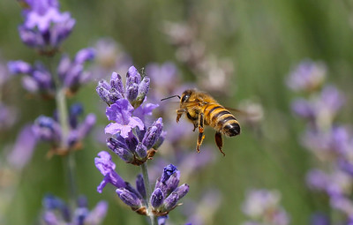

GOOGLE

TAKING NOTES FROM THE RESOURCES I HAVE FOUND

Task / Problem
Subheading | Notes
Expand this chart as you need to complete your notes.
NOTEMAKING OPTION ONE
Task / Problem

Heading 1

Subheading a)

Subheading b)

Subheading c)

Heading 2

Subheading a)

Subheading b)

Subheading c)

Heading 3

Subheading a)

Subheading b)

Subheading c)

Heading 4

Subheading a)

Subheading b)

Subheading c)

NOTEMAKING OPTION TWO
Topic:___________________________________________________________________

Focus Question:__________________________________________________________

NOTEMAKING OPTION THREE

Topic:_______________________________________________________________________________

Focus Question:______________________________________________________________________

PRESENTING YOUR WORK
The presentation format you use will greatly depend on the purpose and audience for your tasks. Listed below are a range of presentation and digital storytelling tools that you may consider using for your final product. To get more information on how to create dynamic projects visit the Research Safari website.

Slideshow Presentation | Brochure | Poster | Digital Story
Report | Podcast | Website | Journal / Diary
Model | Documentary | Cartoon / Animation | Movie

Make some notes here about how you are going to present your work.

WRITING YOUR BIBLIOGRPAHY
A bibliography is a list of resources used in preparing a piece of work.
When writing up a piece of work you will need to cite (quote) the bibliographical references of all resources you have used. There are many different referencing formats you can use. MAKE SURE YOU KNOW WHICH FORMAT IS USED AT YOUR SCHOOL AND FOLLOW THAT ONE. The example below is from the Harvard Referencing System.
Bibliographical references need to be cited in two different places:
- Where a document is referred to in the text.
- In a list at the end of the work, which is arranged alphabetically by author, then by date. This author/date system of description is referred to as the Harvard System.
Books (incl. Reference)
Include the following information in this order:
1. Author’s surname, (comma) initials. (full stop)
2. Date, (comma)
3. Title of book, (italics) (comma)
4. Publisher, (comma)
5. Place of publication. (full stop)
For a reference book:
Title of book, (italics) (comma)
Year, (comma)
Edition, (comma)
Publisher, (comma)
Place of publication. (full stop)
Dixon, J. 1993, How to be a successful student, Penguin Books, Ringwood.

Books (Edited)
Include the following information in this order:
1. Editor’s surname, (comma) initials. (full stop)
2. Year, (comma)
3. Title of book, (italics) (comma)
4. Publisher, (comma)
5. Place of publication. (full stop)

Harvey, J. 2002, Water pollution, Penguin Books, Ringwood.

For an Article in an edited book:
Bryant, S. 1999, ‘The energy crisis of 1920’, in P. Jarman (ed.) Worldwide energy, Blackwell, Sydney.
Interviews
Include the following information in this order:
1. Surname of person being interviewed, (comma) initials. (full stop)
2. Month and Year of interview, (comma)
3. Title of interview, (italics) (comma)
4. Interviewer’s name
5. Type of interview e.g. tape recording, transcript, video recording [in square brackets]
6. Place of interview. (full stop)
Berger, P. Aug 2002, Teaching in L.A., Interviewed by J. Smith [Transcript of Interview] Melbourne Conference Centre.

Journal Articles
Include the following information in this order:
1. Author’s surname, (comma) initials. (full stop)
2. Date, (comma)
3. Title of the article, (in single quotation marks) (comma)
4. Title of the journal, (italics) (comma)
5. Volume, (comma) number, (comma) month/season, (comma)
6. Page numbers of article. (full stop)
Burns, S. 1989, ‘There’s more than one way to learn’, Australian Wellbeing, Vol. 6, No 33, October, pp42-44.

Newspaper Articles
Include the following information in this order:
1. Author’s surname, (comma) initials. (full stop)
2. Date, (comma)
3. Title of the article, (in single quotation marks) (comma)
4. Title of the newspaper, (italics) (comma)
5. Date of publication, (comma)
6. Page numbers of article. (full stop)
Popham, B. 1997, ‘Saving the future’, Weekend Australian, 7 February, p2.

Videos
Include the following information in this order:
1. Title (italics)
2. Date, (comma)
3. Format, (video recording) (comma)
4. Publisher, (comma)
5. Place of publication. (full stop)
South American wetland 1982, video recording, BBC, London.
World Wide Web
Include the following information in this order:
1. Author – person or organisation responsible for the site
2. Site date, the date the site was created or last revised (comma)
3. Name of sponsor or publisher, (comma)
4. Place of sponsor or publisher, (comma)
5. Date of viewing of the site, (comma) year, (comma)
6. URL. (full-stop)
Department of Finance and Administration 2001, Department of Finance and Administration, Canberra, viewed 7 August, 2001, http://www.finance.gov.au.

Write your bibliography here for all of the resources you have used in your inquiry. Put each citation on a different line in this table.

EVALUATING MY WORK
The evaluation stage is perhaps one of the most important stages of the Research Process. Not only does it give you a chance to see how well you did in the task but it also helps you to identify the areas you may need to work on in the future.
Some of the questions you would ask yourself are:
How did I go?

What did I do well?

What did I struggle with?

What do I need to improve next time?

What are five key things I learned from this task?
1)

2)

3)

4)

5)

How will this learning make a difference time?

What is one skill I need to work on for my next assignment?

How else could I have done this task?

Add any other information you may need for your assignment here.

