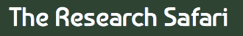
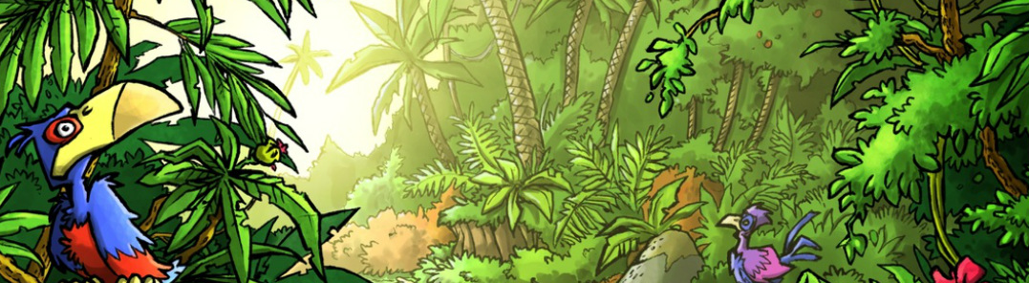
Mini Safari Six

Name:_________________________________________________________________
This mini research safari is designed to get you searching for answers using a range of online search tools. Look at the question carefully to see what kind of information it is asking you to provide.

- Where will you find your metatarsals?

- What is the difference between a butterfly and a moth?

- What is the ingredient in bread that activates the yeast so the bread will rise?

- When did Australia change its currency from pounds, shillings and pence to decimal currency?

- What is the biggest monolith in the world and how big is it?

- If it is 8am in Sydney, Australia, what time is it in Chicago, USA

- Where is the Canal du Midi and what kind of transport uses it?

- Before modern medicine what animal was used to clean infections and wounds?

- Which is longer - The Suez Canal or the Panama Canal - and by how much?

- List at least 10 things that palm oil is used for.

