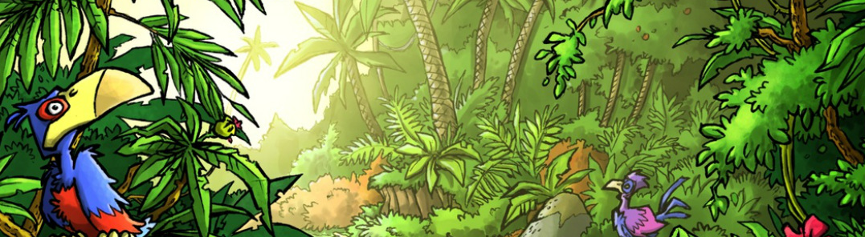
Mini Safari Nine

Name:_________________________________________________________________

This mini research safari is designed to get you searching for answers using a range of online search tools. Look at the question carefully to see what kind of information it is asking you to provide.

- What does VOIP stand for and give three examples of applications where it is used.

- If someone is a haemophiliac what does that mean?

- How many sonnets did William Shakespeare write?

- What is the difference between treacle and molasses?

- What is the shortest distance across Bass Strait between mainland Australia and Hobart?

- How are cyclones named? Which is the most famous Australian cyclone? Where and when did it occur?

- Name 10 different stringed instruments (e.g. violin)

- Who is Australia’s most famous female opera singer?

- What does acapella mean?

- Which happened first – The Eureka Stockade or the capture of Ned Kelly? How many years apart were they?

