DEVELOPING FOCUS QUESTIONS – CANE TOADS

Use the following question starters to develop some of your own questions about Cane Toads. You can then use these questions to guide your inquiry.
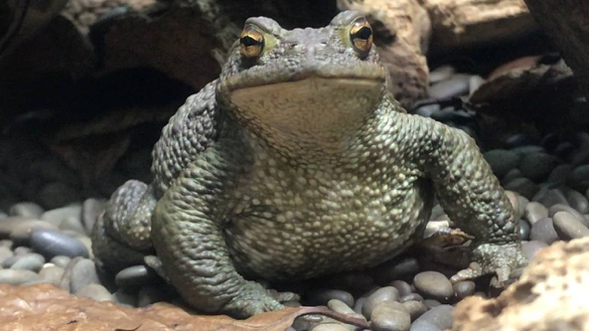
Questions starter | Write your questions here
Who?
What?
Where?
When?
Why?
How?

